EXERCISE NO: 2
DATE:24.10.2020
AIM:
To write a python program, to count the number x in a given list of numbers.

PROGRAM:
def count(lst, x):
count = 0
for ele in lst:
if ele == x :
count=count+1
print(count)
lst =[]
n = int(input())
for i in range (0,n):
ele = int(input())
lst.append (ele)

x = int(input ())
count(lst, x)
LINK:
http://103.53.53.18/mod/vpl/forms/submissionview.php?id=230&userid=1757
OUTPUT

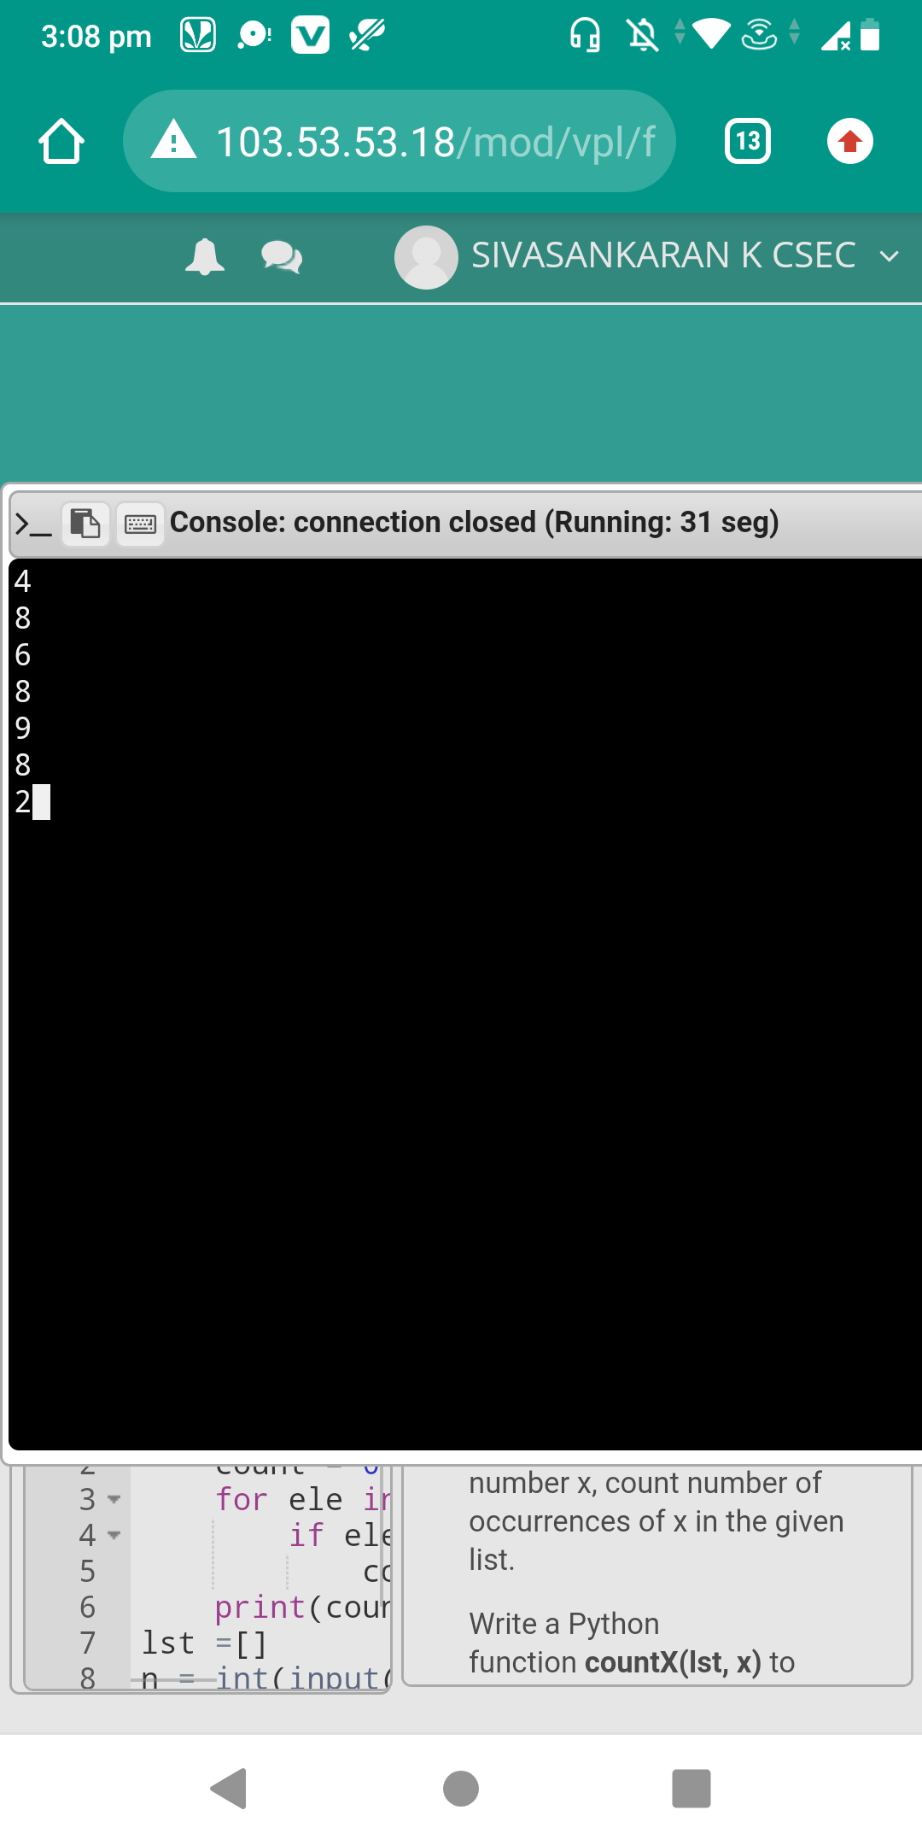
RESULT:
Counting the number x in a given list of numbers is done.

